**VIETNAM NATIONAL UNIVERSITY, HO CHI MINH CITY**

**UNIVERSITY OF INFORMATION TECHNOLOGY**

**FACULTY OF COMPUTER ENGINEERING**

**Full name: Đỗ Thanh Sơn Full name: Trương Hữu Trường Sơn**

**Student ID: 21522551 Student ID: 21522559**

**Class: CE224.O13.MTC Class: CE224.O13.MTC**

**CAPSTONE PROJECT**

**FALL DETECTION SYSTEM AND**

**LOCATION AWARENESS**

**HỆ THỐNG PHÁT HIỆN NGÃ**

**VÀ NHẬN BIẾT VỊ TRÍ**

**FINAL-TERM CAPSTONE PROJECT REPORT**

**MENTOR**

**PhD. TRI NHUT DO**

**VIETNAM NATIONAL UNIVERSITY SOCIALIST REPUBLIC OF VIETNAM**

**HO CHI MINH CITY Independence – Freedom – Happiness**

**UIVERSITY OF INFORMATION**

**TECHNOLOGY**

**FALL DETECTION SYSTEM AND**

**LOCATION AWARENESS PROJECT**

|  |  |
| --- | --- |
| **VIETNAMESE PROJECT NAME: Hệ thống phát hiện ngã và nhận biết vị trí** | |
| **ENGLISH PROJECT NAME: Fall detection system and**  **location awareness** | |
| **Instructor PhD. Tri Nhut Do, Faculty of Computer Engineering** | |
| **Implementation time: From: 1/10/2023 To: 1/11/2023** | |
| **Student Perform: Truong Huu Truong Son – 21522559; Do Thanh Son - 21522551** | |
| **Overview the topic: Fall detection system and location awareness involve developing systems and technologies to reliably identify falls and determine the precise location of individuals, with applications in safety monitoring.**  **The goal of the subject: The primary goal is to enhance safety and well-being by swiftly detecting falls and providing location information for timely assistance.**  **Methods of implementation: Implementation methods include wearable sensors, GPS.**  **Main contents of the topic: Key topics include sensor technologies, fall detection algorithms, data analysis, wearable devices, emergency response integration.** | |
| **Certification of Instructor** | **HCM City, 2023 November 19th**  **Student** |

TABLE OF CONTENT

**CHAPTER 1. INTRODUCTION** 5

1.1 Abstract 5

1.2 Literature review 5

1.3 Purpose and Fuction 5

1.3.1 Purpose 5

1.3.2 Fuction 6

**CHAPTER 2. THEORY BASIS** 7

2.1 Wifi Manager Library 7

2.1.1 What is Wifi manager? 7

2.1.2 How does wifimanger work? 7

2.2 GPS libraries 9

2.3 Geographic coordinates 10

2.4 Mobile app development with MIT App Inventor 11

2.4.1 Development Tool: MIT App Inventor 11

2.4.2 App Functionality 11

2.5 Real-time Database Integration with Firebase 12

2.5.1 What is Firebase Realtime Database? 12

2.5.2 Firebase Realtime Database Functionality 13

2.6 Accelerometer and Gyroscope 14

2.6.1 Accelerometer 14

2.6.2 Gyroscope 14

**CHAPTER 3. SYSTEM DESIGN** 15

3.1 Project layout 15

3.2 Hardware Design 16

3.2.1 Block Diagram 16

3.2.2 Circuit diagram 18

3.3 Sorfware Design 19

3.2.1 Flowchart 19

3.2.2 Algorithm 21

3.2.3 Source code 34

**CHAPTER 4. EXPERIMENT AND TEST RESULTS** 35

4.1 Threshold establishment 35

4.1.1 First Group 35

4.1.2 Second Group 36

4.2 Experiment setting 37

4.3 Experiment scenario 38

**CHAPTER 5. SUMMARY, RESTRICTIONS AND DEVELOPMENT ORIENTATIONS** 40

5.1 Summary 40

5.2 Limitations 40

5.3 Future Development Directions 40

REFERENCES 41

LIST OF FIGURES 41

LIST OF TABLES 42

CONTRIBUTION 42

# **CHAPTER 1. INTRODUCTION**

## 1.1 Abstract

Fall Detection System and Location Awareness are crucial for ensuring the safety of individuals in real-world scenarios. This project represents the actual implementation of a wearable device equipped with simple yet effective capabilities. It is designed to detect falls accurately and provide real-time location awareness. By focusing on monitoring these key motion parameters, the system ensures that individuals are safeguarded in their daily activities, making it a practical and tangible solution for enhancing personal safety.

## 1.2 Literature review

Numerous fall detection methodologies have been extensively researched and implemented across various facets of our daily lives. One prominent approach involves the integration of motion sensors, specifically accelerometers and gyroscopes. These sensors offer direct insights into both linear and angular motion, proving to be invaluable in the identification of genuine falls. Gyroscopes furnish valuable data regarding angular velocity, while accelerometers contribute vital information about linear motion. The amalgamation of these two sensor types significantly augments the accuracy of fall detection, surpassing the performance of a solitary accelerometer by more than 15%.

It is imperative to acknowledge that employing a greater number of sensors inevitably leads to increased power consumption. Consequently, there arises a challenge in designing algorithms adept at effectively fusing data from various sensor sources. Notably, for the specific task of human fall detection, sensors like the MPU6050 have proven to be sufficiently equipped for extracting essential information from their measurements.

In the context of this paper, a fall detection system is developed, centered around a wearable device. The hardware and software architecture of this device predominantly relies on the utilization of MPU6050, GPS NEO. Importantly, the device employs a resource-efficient and low-power consumption fall detection algorithm, rendering it a practical choice for indoor applications.

## 1.3 Purpose and Fuction

### 1.3.1 Purpose

The primary purpose of this project is to develop a wearable device that revolutionizes fall detection and location awareness. This device aims to address the limitations present in current systems by combining simplicity, accuracy, and real-time tracking capabilities. The purpose encompasses:

+ Enhancing Safety: By accurately identifying falls and providing immediate location data, the project strives to enhance the safety of individuals in indoor settings.

+ Prompt Emergency Response: The core goal is to ensure rapid response in emergency situations, minimizing the time between a fall occurrence and the arrival of assistance

+ Reliability and Accuracy: The system aims to minimize false alarms and accurately distinguish between regular movements and actual falls, improving overall reliability.

+ Accessibility: The project intends to create an affordable solution that can be accessible to a wide range of users, irrespective of economic backgrounds.

### 1.3.2 Fuction

Figure . System architecture

The system's architecture, as illustrated in Figure 1, centers around a wearable device securely positioned at the waist of the user. This innovative system is adept at detecting falls. Upon detecting a fall event, it promptly ascertains the geographical location of individual and initiates the transmission of a concise fall alarm to an App . This rapid response mechanism ensures that individuals who have experienced a fall receive timely assistance, thereby minimizing any adverse consequences.

# **CHAPTER 2. THEORY BASIS**

## 2.1 Wifi Manager Library

### 2.1.1 What is Wifi manager?

The WifiManager is a library for configuring ESP8266 to connect to a local WiFi network using a web interface. By initiating a dedicated WiFi network, ESP8266/NodeMCU allows other devices such as computers and smartphones to connect, redirecting all connections to the web interface created by ESP8266/NodeMCU. On this interface, users are provided with information to easily scan nearby networks, select a WiFi network, input a password, and save configurations.

### 2.1.2 How does wifimanger work?

Figure . Demonstration code for using Wifi Manager Library

When the ESP8266/NodeMCU boots up, by default, it will enter STATION mode and automatically connect to an Access Point using the saved connection information from the previous successful connection.

If the connection attempt fails (which could happen if the previous Access Point is no longer available, or if the password is incorrect, or if there is no saved information), the ESP8266/NodeMCU will enter AP mode. In this mode, it becomes an Access Point with its DNS pointing to itself and initiates a Web Server with the default address set to 192.168.4.1.

Devices that support Wi-Fi and have a web browser (such as smartphones, laptops, tablets, etc.) to connect to the newly created Access Point of the ESP8266/NodeMCU.

Typically, this will be a new Wi-Fi network with the name "Fall Detection Device," as shown in the following image:

Figure . Setup wifi for "Fall detection Device"

## 2.2 GPS libraries

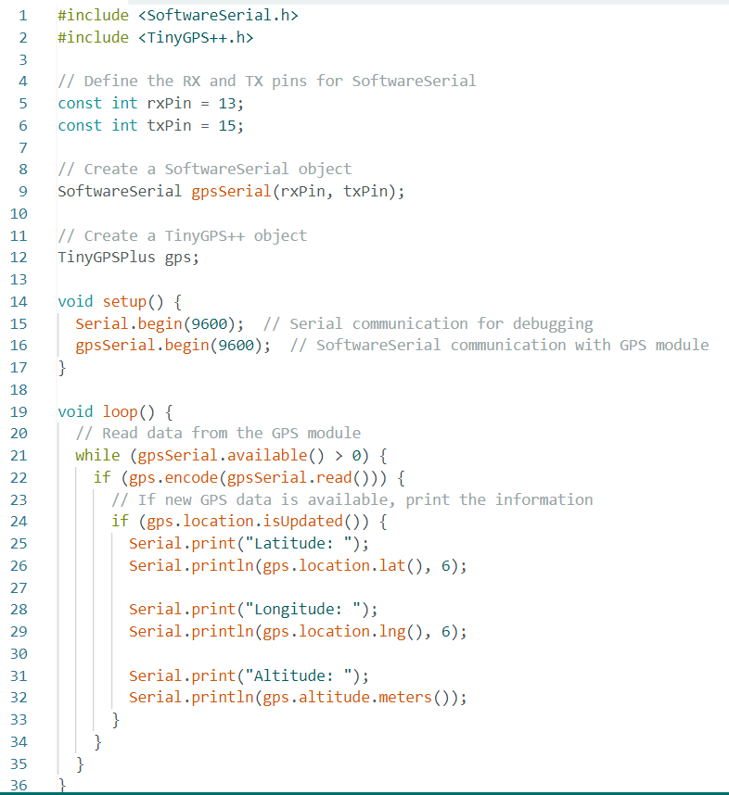

Figure . Demonstration code for using SoftwareSerial and TinyGPS libraries

SoftwareSerial.h is a library in Arduino that allows you to create a software-based serial communication port on any of the digital pins of the Arduino board. This is useful when you need additional serial ports for communication with other devices, as not all Arduino boards have multiple hardware serial ports.

TinyGPSPlus.h is a library designed for parsing NMEA data from GPS modules. It simplifies the process of extracting relevant information such as latitude, longitude, altitude, and more from the raw data received from GPS modules. It provides an easy-to-use interface for working with GPS data.

## 2.3 Geographic coordinates

Latitude: Latitude specifies the north-south position of a point on the Earth's surface. It is measured in degrees, with the equator at 0 degrees latitude and the poles at 90 degrees north and south latitude, respectively.

Longitude: Longitude indicates the east-west position of a point on the Earth's surface. It is also measured in degrees, with the prime meridian at 0 degrees longitude and values ranging up to 180 degrees east or west.



Figure . Demonstration of Latitude and Longtitude

Altitude: Altitude, also known as elevation or height above sea level, represents the vertical distance of a point on the Earth's surface above or below a reference point, usually mean sea level. It is measured in meters or feet.

Figure . Demonstration of Altitude

## 2.4 Mobile app development with MIT App Inventor

### 2.4.1 Development Tool: MIT App Inventor

MIT App Inventor is a web-based tool for developing Android mobile applications that allows users to create apps without requiring deep programming skills. With a visual interface and the ability to drag and drop "blocks" to build functionality, App Inventor is suitable for beginners in mobile app development and is widely used in education. This tool supports various features, including sensors, network connectivity, and interaction with databases.

### 2.4.2 App Functionality

Slidebar contents contain:

- Status Section:

User Status: Indicates whether the user is currently standing or has experienced a fall.

Coordinates: Displays three crucial geographical coordinates - longitude, latitude, and altitude - providing the precise location of the user.

- Map Location Section:

Marker Display: Illustrates the user's current location with a marker on the map.

Google Map View Button: Enables users to view their location on Google Maps directly from the application.

Coordinate Sharing Button: Allows users to share their coordinates with multiple applications for additional functionalities.

- Setting Section:

Threshold Setup: Provides the option to set a threshold for fall detection, allowing users to customize the sensitivity of the system.

Angle Fall Setup: Allows users to configure the angle of fall for the device, enhancing the adaptability of the fall detection mechanism.

The fall detection mobile application comprises three main sections, accessible through a sliding sidebar:

Figure . Slidebar on mobile app

Source App: https://drive.google.com/file/d/1xB_vrccJUdR_U2U-WW3wS0urMfiUT4-Y/view?usp=sharing

1. Status section
2. Setting section

1. Map location section

## 2.5 Real-time Database Integration with Firebase

### 2.5.1 What is Firebase Realtime Database?

Firebase Realtime Database is a part of the Firebase suite, a set of development platforms and cloud computing services offered by Google. Specifically, the Realtime Database is a cloud-hosted NoSQL database that allows developers to store and synchronize data in real-time across multiple clients. It is well-integrated with various platforms and languages, including Android, iOS, JavaScript, Node.js, Java, Unity, PHP, and C++.

### 2.5.2 Firebase Realtime Database Functionality

Figure . Firebase Realtime Database

The Realtime Database for this fall detection system is structured into a single group, encompassing essential parameters:

/gps

/altitude: Records the altitude information.

/Fall: Indicates the fall event, providing real-time updates.

/latitude: Stores the latitude coordinates of the user's location.

/longitude: Stores the longitude coordinates of the user's location.

/angle_fall: Set the fall angle of the fall event.

/lower_threshold: Sets the lower threshold for fall detection sensitivity.

/upper_threshold: Establishes the upper threshold for fall detection sensitivity.

By utilizing Firebase Realtime Database, the fall detection system can seamlessly store, update, and retrieve critical data in real-time, facilitating instantaneous communication between the wearable device and the associated mobile application. This integration enhances the overall responsiveness and reliability of the fall detection system, ensuring timely and accurate transmission of crucial information.

## 2.6 Accelerometer and Gyroscope

### 2.6.1 Accelerometer

An accelerometer is a vital sensor employed to quantify acceleration, a parameter defined as the speed at which an object accelerates or decelerates while moving in a specific direction. In its physical form, an accelerometer is crafted as a microelectromechanical system (MEMS) device, meticulously manufactured through microfabrication technology. This intricate process involves a multilayer wafer fabrication, where the accelerometer gauges acceleration forces by discerning the displacement of a mass concerning stationary electrodes. Essentially, accelerometers play a crucial role in diverse applications, ranging from smartphones and wearable fitness devices to automotive safety systems, providing valuable data by precisely capturing changes in velocity and movement.

Figure . Demonstration of the axis of Accelerometer

### 2.6.2 Gyroscope

A gyroscope is a device designed to apply the principles of conserving angular momentum for the purpose of measuring or maintaining orientation. This sensor operates by utilizing the concept of angular momentum conservation, enabling accurate detection and tracking of changes in orientation. Gyroscopes find widespread applications in various fields, from navigation systems in aircraft and spacecraft to stabilization mechanisms in electronic devices, playing a crucial role in preserving and determining directional information.

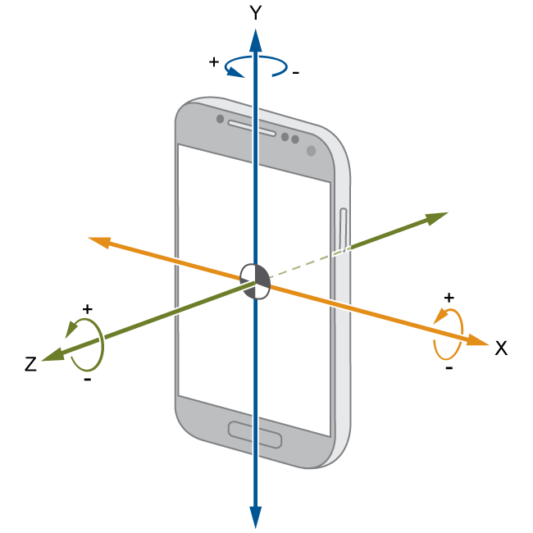

Figure . Demonstration of the axis of Gyroscope

# **CHAPTER 3. SYSTEM DESIGN**

## 3.1 Project layout

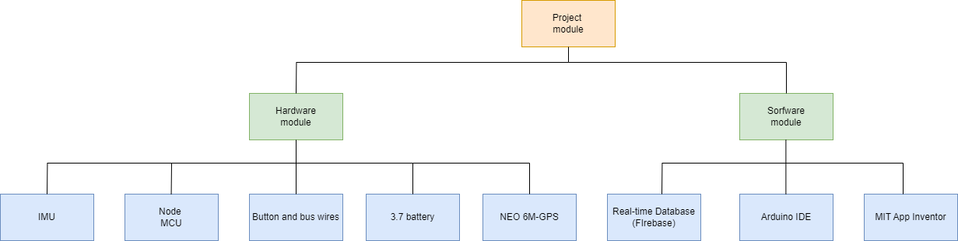

Figure . Layout of project module

Node MCU (ESP8266): Node MCU is the microcontroller unit in the prototype. It has an inbuilt Wi-Fi module (ESP8266) that establishes wireless remote switching of home appliances.

IMU (Inertial Measurement Unit): The IMU, utilizing components such as the MPU6050, detects and monitors the user's movement and orientation to identify potential falls in real-time.

Button and Bus Wires: The button, along with bus wires, provides manual control or input for the user to withdraw the action of falling, interrupting the fall detection process if necessary.

Neo-6M GPS: The Neo-6M GPS module retrieves real-time geographical coordinates, enabling accurate location tracking and data about the user's position.

Real-time Database (Firebase): The Real-time Database, powered by Firebase, serves as the central repository for storing, retrieving, and managing data related to fall detection events, user coordinates, and status.

Arduino IDE: The Arduino Integrated Development Environment (IDE) is utilized for writing, compiling, and uploading code to the Node MCU (ESP8266) to manage the functionality of the prototype and the interaction between the various hardware components.

MIT App Inventor: The MIT App Inventor is employed to create a user-friendly smartphone application, allowing users or caregivers to access and visualize the data from the Real-time Database (Firebase), providing insights into the user's fall status and coordinates in real-time.

## 3.2 Hardware Design

### 3.2.1 Block Diagram

#### a) Node MCU

NodeMCU (Node Microcontroller Unit) is a low-cost open source IOT platform. It initially included firmware which runs on the ESP8266 Wi-Fi SoC from Espressif Systems, and hardware which was based on the ESP-12 module. Later, support for the ESP32 32-bit MCU was added.

Figure . Node MCU Development Board.

NodeMCU is an open source firmware for which open source prototyping board designs are available. The name “NodeMCU” combines “node” and “MCU” (micro-controller unit). The term “NodeMCU” strictly speaking refers to the firmware rather than the associated development kits. Both the firmware and prototyping board designs are open source. The firmware uses the Lua scripting language. The firmware is based on the eLua project, and built on the Espressif Non-OS SDK for ESP8266. It uses many open source projects, such as luacjson and SPIFFS. Due to resource constraints, users need to select the modules relevant for their project and build a firmware tailored to their needs. Support for the 32-bit ESP32 has also been implemented.

The prototyping hardware typically used is a circuit board functioning as a dual in-line package (DIP) which integrates a USB controller with a smaller surface-mounted board containing the MCU and antenna. The choice of the DIP format allows for easy prototyping on breadboards. The design was initially was based on the ESP-12 module of the ESP8266, which is a Wi-Fi SoC integrated with a Tensilica Xtensa LX106 core, widely used in IOT applications.

#### b) NEO-6M GPS Module

The NEO-6M is a widely used and relatively low-cost GPS (Global Positioning System) module. It is commonly utilized in a variety of applications where accurate positioning and location data are required.

Figure . NEO-6M GPS Module

The NEO-6M GPS module is a versatile and cost-effective solution for adding GPS capabilities to a wide range of projects, including vehicle tracking systems, location-based services, geocaching devices, drones, and more. Its ease of integration, accuracy, and fast time to first fix make it a popular choice for many GPS-related applications.

#### c) MPU6050 Module

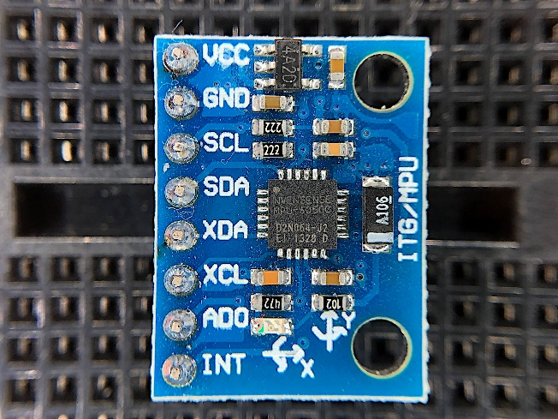

Figure . MPU6050 Module

A highly well-liked accelerometer gyroscope chip with six sensed axes and a 16-bit measurement resolution is the MPU6050. A gyroscope and an accelerometer are used to create an inertial measurement unit, or IMU. IMU sensors are used in many different types of devices, including smartphones, tablets, satellites, spacecraft, drones, unmanned aerial vehicles (UAVs), robots, and many more. They are used for aircraft control, orientation and position sensing, motion tracking, and other functions.

#### d) Hardware structure

Figure . Basic hardware structure

The NodeMCU serves as the control unit, collecting data from the MPU6050 and GPS module, and when a fall is detected, it can send an alert to mobile app through wifi to notify relevant parties. The MPU6050's motion data and the NEO-6M GPS data are crucial for detecting a fall event accurately.

### 3.2.2 Circuit diagram

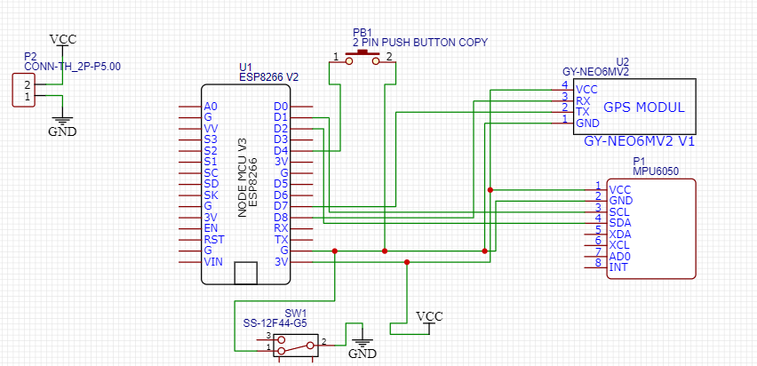

Figure . 3D Schematic of Fall Detection Device

## 3.3 Sorfware Design

### 3.2.1 Flowchart

Figure . Flow chart

#### 3.2.1.1 Flow chart of fall detection algorithm

Figure . Flow chart of fall detection algorithm

### 3.2.2 Algorithm

#### a) Data accquisition and calibration

- Gyroscope initial:

Figure . Reading signals gyroscope from MPU6050

+ Explanation:

(72-75): Switch on low pass filter

Figure . Low pass filter accorrding to MPU6050 datasheet

(76-79): Set the sensitivity scale factor

(76-79): Set the sensitivity scale factor(+-500 deg/s)

Figure . Set the sensitivity scale of gyroscope.

(80-82) : Access registers storing gyro measurements

Figure . Access register storring gyroscope measurements

(83-86): Read the gyro measurements around the X axis

Figure . Gyroscope measurements around the x axis

(98-100): Convert the measurements units to degree/s

Figure . Setup clock and calibration of gyroscope

(145): Set the clock speed of I2C

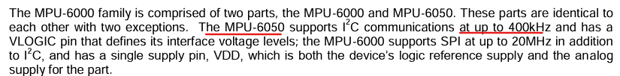

Figure . Clock speed according to MPU6050 Datasheet

(149-151) Set to zero (wakes up the MPU-6050)

(152-164) Perform the calibration measurements aand caculate the calibration values

Figure . Gyroscope values after calibration

(250-253) Gyroscope values after calibration

- Accelerometer initial:

Figure . Reading signals accelerometer from MPU6050

+ Explanation:

(87-90): Configure the accelerometer output (+-8G).

Figure . Set accelerometer scale range

(91-97): Pull the accelerometer measurements from the sensor.

Figure Access accelerometer registers

Figure . Accelomete values after calibration

(101-103): Convert the measuremnets to physical values and remove off-set

#### b) Record g(before) as standing position

Figure . Caculate based angle for one second intervals.

- Explanation:

The function Alpha_Degree() computes the roll angle using a one-dimensional Kalman filter. The filter processes the gyroscope data (RateRoll) and accelerometer data (AngleRoll) to estimate and refine the roll angle, providing a more accurate measurement in KalmanAngleRoll. The uncertainty or variance in this angle estimation is stored in KalmanUncertaintyAngleRoll.

Within the loop(), the angle is calculated at 1-second intervals (count <= 250). The Alpha_Degree() function is called to compute the angle, and the count is incremented. Once the count reaches 250, the program prints messages to the serial monitor indicating the setup for accelerometer and gyroscope ranges, and it announces the calculation of the angle based on the provided data.

Utilizing a Kalman filter to refine the angle estimation over time.

#### c) Compute Angle Roll using Kalman Filter

- Caculate Angle Roll using accelerometer:

This formula utilizes accelerometer data to estimate the roll and pitch angles. It leverages the relationships between the different axes of the accelerometer (typically measuring acceleration due to gravity) to determine the device's orientation relative to the ground.

For the roll angle calculation (AngleRoll), the formula uses the measurements along the Y-axis (representing the device's side-to-side movement) and factors in the square root of the sum of squares of the X and Z-axis values. By applying the arctangent function, it computes the angle necessary to align the Y-axis with the gravity vector, essentially providing the angle at which the device is tilted sideways.

Similarly, for the pitch angle (AnglePitch), it involves the X-axis (representing the device's front-to-back movement) and uses the Y and Z-axis measurements. The formula determines the angle required to align the X-axis with the direction of gravity, indicating the forward or backward tilt of the device.



Figure . Fomula for caculating Angle Roll (accelerometer)

- Caculate Roll Rate using gyroscope:

A 250 Hertz loop, the method for calculating the current angle based on the rotation rate and the time interval. The formula involves summing the rotation rates multiplied by the iteration time (in this case, 4 milliseconds) to the angle from the previous iteration to obtain the angle for the current iteration. However, the passage of measurement errors from previous iterations introduces a rapid drift in the calculated angle, impacting its accuracy and reliability.

Moreover, the formula highlights a crucial problem: the gyroscope-based approach isn't immune to changes in angles during movement.

Figure . Fomula for caculating Roll Rate(gyroscope)

- Kalman Filter 1-Dimensional:

Figure . Comparision Roll Angle(accelerometer) and RateRoll(gyroscope)

Figure . Comparision Roll Angle (Kalman Filter) and Roll Angle(accelerometer)

- Reason why we use Kalman Filter:

Employing a one-dimensional Kalman filter for fall detection offers a precise and effective method for estimating body orientation crucial in identifying potential falls. The filter's one-dimensional implementation simplifies the fusion of sensor data, such as accelerometer or gyroscope measurements, focusing specifically on the angle of orientation. This simplified model reduces computational complexity while effectively handling noisy sensor data, enhancing the accuracy of angle estimation. In fall detection systems, where swift and accurate recognition of changes in body position is critical, the one-dimensional Kalman filter proves beneficial by offering a streamlined yet robust means to continuously monitor and interpret angular changes. Its ability to handle sensor data integration and mitigate measurement errors ensures a more reliable determination of body orientation, aiding in distinguishing normal movements from fall-related dynamics. Consequently, the one-dimensional Kalman filter serves as a valuable tool in fall detection systems, enabling real-time and precise identification of potential falls based on subtle changes in body angle.

- Kalman 1D main fomula:

Figure . Karman 1-Dimensional Main Fomula

This filter combines the predicted angle with a correction factor based on the difference between the measured angle (calculated using accelerometer trigonometry) and the predicted angle.

The Kalman filter uses a concept known as the Kalman gain, which adjusts the predicted angle by considering both the existing prediction and the difference between the predicted angle and the angle obtained from the accelerometer's measurements. The accelerometer-derived angle represents the 'measured angle' in this context.

By multiplying the Kalman gain with the difference between the predicted angle and the measured angle, the filter updates its prediction. This process leverages the information from both the prediction and the new measurement, adjusting the predicted angle to minimize errors and provide a more accurate estimation that incorporates information from both the prediction and the actual measurement obtained from the accelerometer data.

Figure . Caculate KalmanAngleRoll

- Kalman Gain fomula:

Figure . Kalman Gain Fomula

The Kalman gain serves as a pivotal factor in the Kalman filter, defining the relative ratio between the uncertainty or variance in the predicted angle and the uncertainty in the measured angle. It quantifies how much emphasis or weight the filter places on the new measurement (in this case, obtained from the accelerometer) compared to the existing prediction.

The equation for updating the Kalman gain utilizes the standard deviation of the accelerometer's measurement error. In this scenario, the standard deviation of the accelerometer measurement error, assumed to be 3 degrees, is crucial in determining the weight given to the new measurement. The Kalman gain is derived from a relationship between these uncertainties, adjusting the contribution of the new measurement to the final estimation.

- Breakdown the code for Kalman Filter 1-Dimensional:

Figure . Kalman 1-Dimensional Filter

Figure Walkthrough caculation of KalmanAngleRoll

#### d) Accquiring thresholds

- Accquisition lower threshold, upper threshold, and orientation fall:

Accelerometer and gyroscope data obtained from an ESP8266 and MPU6050 are leveraged to capture the signals representing the movements. These signals are used to compute the Acceleration-Gravity Vector and Estimated Sensor Resultant (AGVeSR) magnitude. The objective is to discern specific actions, notably falling and jumping, which typically generate substantial acceleration patterns.

This approach facilitates the development of a system that can recognize and differentiate distinct movement patterns, specifically those associated with falls, by examining and evaluating key features extracted from the accelerometer and gyroscope data.

Figure . Measuring threshold code

Figure . Reading values from COM port using CoolTerm.

Figure . Line chart based on COM port data.

#### e) AGVeSR method

The AGVeSR (Resultant Acceleration method) introduced in this scenario combines data from both accelerometer and gyroscope sensors to enhance the accuracy of detecting human movements, particularly falls or other daily activities. By integrating information from the six axes—three from the accelerometer (AX, AY, AZ) and three from the gyroscope (GX, GY, GZ)—this method creates a comprehensive view of human motion. The implementation of the AGVeSR formula doesn’t rely on specific device orientations but instead uses absolute notation to capture the overall movement irrespective of the sensor's positioning. By considering absolute values, the method normalizes data, ensuring that whether an axis registers a negative or positive value, the resulting absolute value aids in the calculation of sensor data. This approach enhances the sensor's capability to recognize various human activities, regardless of the smartphone's positioning, making it more versatile and adaptable to unconstrained sensor placements.

Figure . AGVeSR fomula

#### f) The mechanisms of the system.

Figure . First Trigger as (Impact State)

Figure . Second Trigger as (Record g after)

Figure . Third Trigger as (Record g end)

Figure . Fall detected notification

The program begins by assessing the accelerometer data, initially checking if the values surpass a lower threshold. Upon meeting this condition, the program pauses for half a second before verifying if the values exceed an upper threshold. When the upper threshold is surpassed, the program then proceeds to compute the change in orientation based on the gyroscope data. This change in orientation is monitored for sudden alterations.

Upon detecting a sudden change in orientation, the program initiates a 10-second interval to evaluate if this altered orientation remains consistent over this duration. This sequence of checks and validations allows the program to detect significant changes in movement and orientation. If the orientation remains the same,regard as falling.

### 3.2.3 Source code

Link google drive: https://drive.google.com/file/d/1bxaM65nSPOAUfWeA3pnU0fSmNkMlbbMy/view?usp=sharing

# **CHAPTER 4. EXPERIMENT AND TEST RESULTS**

## 4.1 Threshold establishment

To gauge the accuracy of the proposed models and prototypes, various scenarios were tested. The evaluation process was conducted within two distinct groups, each featuring four different scenarios. The objective was to scrutinize the performance of the proposed approach and its corresponding prototype, which was outfitted with both accelerometer and gyroscope sensors.

### 4.1.1 First Group

Table . Activity daily living(ADL) scenarios

Run

Sit on chair

Walk

Squad

Figure . AGVeSR Magnitude - ADL scenarios ( Peak Magnitude )

Run

Sit on chair

Walk

Squad

Figure . Angle Orientation - ADL scenarios

*- Conclusion*: The AGVeSR magnitude exhibits a peak magnitude of 200, while the associated angle orientation occurs at approximately 20 degrees.

### 4.1.2 Second Group

Table . Falling scenario

Figure . AGVeSR Magnitude - Fall scenarios ( Peak magnitude)

Figure . Angle Orientation - Fall scenarios

-*Conclusion*:

+ As illustrated in Figure 49, a discernible trend emerges, indicating that the "fall backward" scenario consistently exhibits the lowest peak magnitude at 491. This value can serve as the upper threshold for all four fall scenarios. Notably, the peak occurs at 133 milliseconds, implying that the lower threshold could occur anywhere from 10 milliseconds onward, given the 0.5-second interval for the subsequent upper threshold break.

+ To establish a specific lower threshold, we can pinpoint at mark 73 milliseconds, corresponding to an average magnitude of all four scenarios are 150. Concurrently, an upper threshold of 450 presents a balanced choice. This refined analysis provides a clearer delineation of the thresholds, enhancing our understanding of the fall scenarios.

+ In Figure 50, the angle orientations for falling to the left and right are approximately 70 and 89, respectively. Fall backward is at 70, and falling forward is around 70 as well. A prudent choice for setting the angle orientation during a fall is 65, ensuring a reliable threshold.

## 4.2 Experiment setting

Research experiments were conducted utilizing a test subject of 172cm height to investigate fall detection mechanisms. The experimentations employed a defined threshold system outlined in the following algorithm:

Lower Threshold (a): 150

Upper Threshold (a): 450

Angle of Fall (g): 65 degrees

Angle of Stability (g): 10 degrees

- Experimental Setup:

The research was carried out indoors within an apartment environment. The setup included a PCB integrated with an ESP8266 and an MPU6050 sensor. All generated data was seamlessly transmitted to the USB serial port in real-time, enabling immediate access to the serial monitor of Arduino IDE.

- Methodology:

The experiments were systematically executed a total of 160 times. From the conducted experiments, the instances were categorized, distinguishing between the occurrences of falls and the instances related to activities of daily living (ADL).

## 4.3 Experiment scenario

- The assessment for fall detection was conducted on a padded surface, with the subject of the study being a 55 kg male with a height of 172 cm. The wearable device was positioned within the right lower quadrant of the subject. The following scenario outlines a simulated fall event.

Figure . The position of the device

Figure . Fall Detection Device

-Several falling scenarios were exhibited by 1 person who experimented on it 20 times in each scenario.

ADL Experiments was used to determine the accuracy of fall detection algorithms:

Table . Falling result test

Table III showed the accuracy of fall detection algorithm that was applied. Each scenario were carried 20 times for maximum clearance.

Table . Activity daily living result (ADL)

Based on Table IV, the algorithm still detected the occurrence of falling in some daily activities. For instance, during the ADL experiment, 2 of 20 attempts at running were detected as a falling state. When sitting down there were 2 of 20 attempts that were detected as a falling state. In another case, moving down the stairs was also detected as a falling state due to the gravity level affecting the acceleration of the detector device.

# **CHAPTER 5. SUMMARY, RESTRICTIONS AND DEVELOPMENT ORIENTATIONS**

## 5.1 Summary

The development and assessment of a fall detection system tailored for assisting the elderly have yielded promising results. The prototype, strategically positioned at the right lower quadrant of the subject, proficiently gathered sensor data and alongside a threshold detection algorithm for accurate fall detection.

In a series of experiments consisting of 60 simulated falls, the system exhibited an impressive accuracy rate of 90%. Additionally, across 60 comprehensive experimental trials focusing on activities of daily living (ADL), the system showcased an average accuracy of 95%.

## 5.2 Limitations

Component Arrangement: The existing setup lacks a consolidated and portable casing, presenting challenges in terms of portability and user-friendliness. The current configuration, mounted on a PCB, hinders convenient mobility.

GPS Functionality: The detachment of the NEO-6M GPS indoors underscores the limitation of indoor functionality. There is a need for further exploration to improve its reliability in indoor settings or explore alternative location detection mechanisms.

## 5.3 Future Development Directions

The system's capability to swiftly detect a fall event and initiate an alarm represents a significant advancement in ensuring prompt response and intervention. However, it is crucial to recognize that the system's capabilities may need refinement to effectively handle various falling scenarios that could occur in real-world settings.

While this research predominantly emphasizes detection mechanisms, future endeavors could delve into additional features. Integrating functionalities such as the ability to send short messages (SMS) and obtaining precise positioning of the wearable device would substantially enhance the system's efficacy, facilitating timely assistance during emergencies.

# REFERENCES

[1]: Research Article - Development of a Wearable-Sensor-Based Fall Detection System

School of Instrumentation Science and Optoelectronics Engineering, Beihang University, Beijing 100191, China2 Space Star Technology Co., Ltd., Beijing 100086, China

[2]: Accurate, Fast Fall Detection Using Gyroscopes and Accelerometer-Derived Posture Information –

Qiang Li, John A. Stankovic, Mark Hanson, Adam Barth, John Lach University of Virginia

[3]: Human Fall Detection using Accelerometer and Gyroscope Sensors in Unconstrained Smartphone Positions - Maria Seraphina Astriani, Yaya Heryadi, Gede Putra Kusuma, Edi Abdurachman

[4]: Fall Detection System Using Accelerometer and Gyroscope Based on Smartphone - Arkham Zahri Rakhmani , Lukito Edi Nugrohoi , Widyawani , Kurnianingsihi , 2 IDept. of Electrical Engineering and Information Technolog

[5]: Combine a gyroscope and accelerometer to measure angles – precisely - Carbon Aeronautics

# **LIST OF FIGURES**

Figure 1. System architecture 6

Figure 2. Demonstration code for using Wifi Manager Library 7

Figure 3. Setup wifi for "Fall detection Device" 8

Figure 4. Demonstration code for using SoftwareSerial and TinyGPS libraries 9

Figure 5. Demonstration of Latitude and Longtitude 10

Figure 6. Demonstration of Altitude 10

Figure 7. Slidebar on mobile app 11

Figure 8. Firebase Realtime Database 13

Figure 9. Demonstration of the axis of Accelerometer 14

Figure 10. Demonstration of the axis of Gyroscope 15

Figure 11. Layout of project module 15

Figure 12. Node MCU Development Board. 16

Figure 13. NEO-6M GPS Module 17

Figure 14. MPU6050 Module 18

Figure 15. Basic hardware structure 18

Figure 16. 3D Schematic of Fall Detection Device 19

Figure 17. Flow chart 20

Figure 18. Flow chart of fall detection algorithm 21

Figure 19. Reading signals gyroscope from MPU6050 22

Figure 20. Low pass filter accorrding to MPU6050 datasheet 22

Figure 21. Set the sensitivity scale of gyroscope. 23

Figure 22. Access register storring gyroscope measurements 23

Figure 23. Gyroscope measurements around the x axis 23

Figure 24. Setup clock and calibration of gyroscope 24

Figure 25. Clock speed according to MPU6050 Datasheet 24

Figure 26. Gyroscope values after calibration 24

Figure 27. Reading signals accelerometer from MPU6050 25

Figure 28. Set accelerometer scale range 25

Figure 29 Access accelerometer registers 26

Figure 30. Accelomete values after calibration 26

Figure 31. Caculate based angle for one second intervals. 26

Figure 32. Fomula for caculating Angle Roll (accelerometer) 27

Figure 33. Fomula for caculating Roll Rate(gyroscope) 28

Figure 34. Comparision Roll Angle(accelerometer) and RateRoll(gyroscope) 28

Figure 35. Comparision Roll Angle (Kalman Filter) and Roll Angle(accelerometer) 28

Figure 36. Karman 1-Dimensional Main Fomula 29

Figure 37. Caculate KalmanAngleRoll 30

Figure 38. Kalman Gain Fomula 30

Figure 39. Kalman 1-Dimensional Filter 30

Figure 40 Walkthrough caculation of KalmanAngleRoll 31

Figure 41. Measuring threshold code 32

Figure 42. Reading values from COM port using CoolTerm. 32

Figure 43. Line chart based on COM port data. 32

Figure 44. AGVeSR fomula 33

Figure 45. First Trigger as (Impact State) 33

Figure 46. Second Trigger as (Record g after) 34

Figure 47. Third Trigger as (Record g end) 34

Figure 48. Fall detected notification 35

Figure 49. AGVeSR Magnitude - ADL scenarios ( Peak Magnitude ) 36

Figure 50. Angle Orientation - ADL scenarios 36

Figure 51. AGVeSR Magnitude - Fall scenarios ( Peak magnitude) 37

Figure 52. Angle Orientation - Fall scenarios 37

Figure 53. The position of the device 39

Figure 54. Fall Detection Device 39

# **LIST OF TABLES**

Table I. Activity daily living(ADL) scenarios 36

Table II. Falling scenario 37

Table III. Falling result test 39

Table IV. Activity daily living result (ADL) 40

# **CONTRIBUTION**

|  |  |
| --- | --- |
| Task Assignment Table | |
| Members | Tasks |
| Trương Hữu Trường Sơn – 21522559 | -Write report  -Design Fall Detection Algorithm  -Develop App Interface -Manage Sensor Data Accquisition |
| Đỗ Thanh Sơn – 21522551 | -Conducting Experiments  -PCB Manufacture  -Minor contributions to App Interface |